# Module 1 Summative Assessment

**Question 1**

Given the information below, please select which answer is the closest number for moviegoers (number of people who go to the movies) in the northeast United States with the following information.

DEMOGRAPHIC DATA FOR NORTH – EAST UNITED STATES

States included are: Connecticut, Delaware, Maine, Maryland, Massachusetts, New Hampshire, New Jersey, New York, Pennsylvania, Rhode Island, Vermont. Source: 2012 US Census Bureau

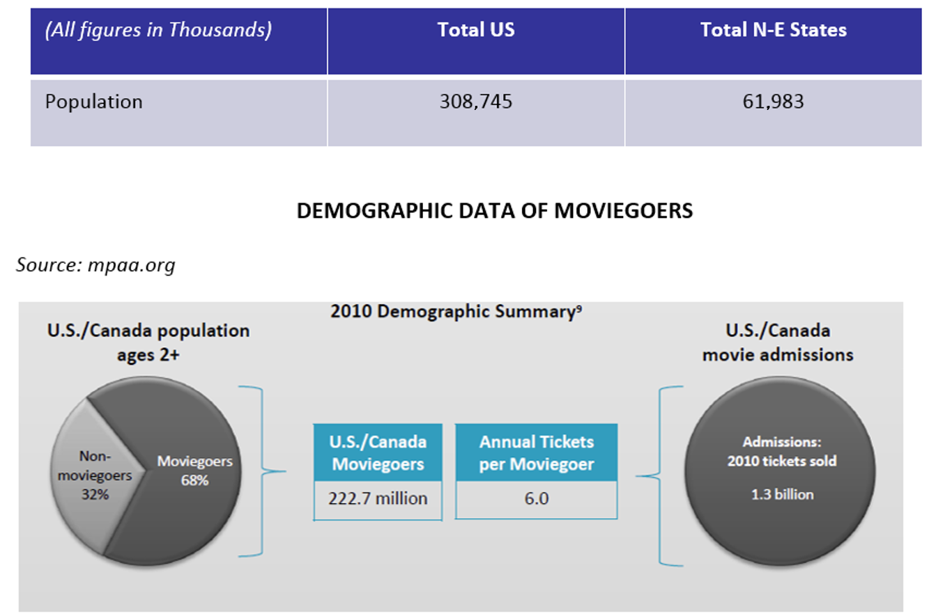

1. 42,148 million
2. 40,690 million
3. 61,983 million
4. 104,634 million
5. None of the above.

Question 2

Using the different types of product categories that we reviewed, please watch the following video (<https://www.youtube.com/watch?v=zlA9tXYxD8g> or <https://vimeo.com/94494054>) and classify the service that Coca-Cola offered with its promotion.

1. Functional, intangible and low involvement.
2. Emotional, tangible, and low involvement.
3. Emotional, intangible and low involvement.
4. Emotional, tangible, and high involvement.
5. Functional, tangible and high involvement.

**Question 3**

If you had launched the lemonade business we discussed

in our lectures in your neighborhood, which of the following phrases best

describes the situation your product may be entering its growth phase?

1. Potential customers don't know about your lemonade yet and there are few competitors.
2. Sales are growing rapidly, but so are the number of competitors. You are developing your sales channels to distribute in as many outlets as possible.
3. Almost everyone in your target group has tried the lemonade and growth comes from substituting other products or new customers entering your target group.
4. Your lemonade is the first one in the marketplace and your marketing efforts are ensuring everyone knows about your product.
5. Your competitors are merging, some are going out of business, and your demand is stable or decreasing.

Question 4

Which of the product strategies below did Apple use when they decided to launch iPhone?

1. Market development.
2. Market penetration.
3. Diversification.
4. Augment the depth of their product mix.
5. Repositioning the brand.

**Question 5**

Imagine that you work for Microsoft and you are doing an analysis of the next step for the Microsoft Windows System. Using the data below, where do you think you would place it within the BCG matrix?

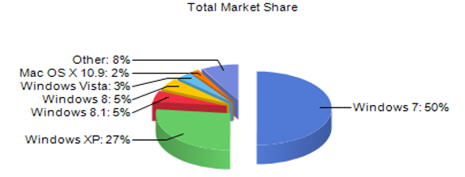

1. Star.
2. Cow.
3. Question mark.
4. You can't analyze this using the BCG matrix.
5. Dog.

**Question 6**

Which of the below is not a keys success factor when launching a new product?

1. Listen to the consumer along the way during the product development cycle and after launch.
2. Get everyone onboard – including those areas/functions not directly involved in the development process.
3. Giving R&D the liberty to come up with whichever product they think will be the next big hit.
4. Set go-no go milestones, with specific decision-making criteria and stick to them.
5. Generate a business case that summarizes the concept’s viability.

# [**Module 2 Summative Assessment**](https://www.coursera.org/learn/brand-management/exam/9AOLg/module-2-summative-assessment)

**Question 1**

What are the key inputs for developing your brand?

1. Essence, values, extended identity.
2. Business strategy, brand image, market trends, customer analysis, competitive analysis.
3. Market development, market penetration, diversification and product development.
4. Top management’s ideas, our agency’s creativity, our sales force’s and our customer service inputs.
5. Relevance, strategic fit, differentiation, credibility.

**Question 2**

Read the following phrase and think about our lemonade business. Select whether the statement is an end-benefit, an attribute or neither for our lemonade buisness:

"**Our lemonade is caring of the environment"**

1. End-benefit.
2. Neither an end-benefit nor an attribute.
3. Attribute.

**Question 3**

In the following advertising, please identify which one is the “reason to believe”:

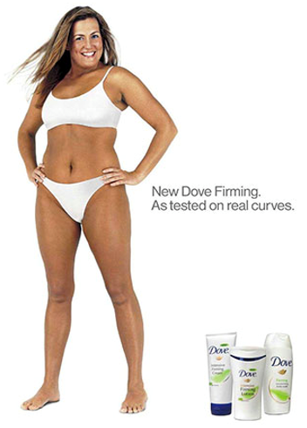

1. The product’s ingredients.
2. The Dove brand.
3. The curves on the model.
4. The model’s bra.
5. The packaging.

**Question 4**

Which of the following is a well-written brand value for innovation for a company in the sports business?

1. For us, Innovation means using the latest technology in all of our products.
2. For us, Innovation means generating new ideas and incorporating new technologies that will make us more competitive.
3. For us, Innovation means enhancing the performance of our customers through the use of technology.
4. For us, Innovation means employees always strive to produce excellent work that pushes the company upward.
5. For us, Innovation is challenging conventional wisdom, finding new ways to surmount existing challenges.

**Question 5**

One of the criteria for evaluating brand strategies is being relevant. Which of the answers below explains what it means to be relevant?

1. It means that all brand-related topics are connected.
2. None of the above.
3. It means that the brand has to use content and sponsorships in a strategic way.
4. It means that the brand has high awareness among all consumers.
5. It means being meaningful to your target customers.

**Question 6**

Read the following three sentences about FedEx and answer the question in bold:

Sentence 1: For business of all sizes, Fedex is the solutions and logistics company that provides peace of mind through unparalleled innovation, quality and consistency.

Sentence 2: Business solutions for your peace of mind.

Sentence 3: Relax, It’s Fedex.

**Which one of these sentences is the company's brand essence?**

1. Sentence 1.
2. Sentence 2
3. Sentence 3

# **Module 3 Summative Assessment**

**Question 1**

What is brand equity?

1. A concept to explain when Brands are cluttered and confusing to both customers and employees.
2. A set of assets (and liabilities) linked to a brand’s name and symbol that adds to (or subtracts from) the value provided by a product or service to a firm and/or the firm’s customers.
3. A concept that summarizes who we are and our key promise to our stakeholders.
4. A set of attributes that summarize how the Brand connects with its stakeholders, i.e. wants to be perceived, and defines the Brand personality / character.
5. It outlines the proof points or what the brand is claiming to credibly deliver on the positioning.

**Question 2**

Which of the below are brand architecture models?

1. House of brands, hybrid and branded house.
2. Introduction, growth, maturity and decadency.
3. Pre-purchase, purchase and post-purchase.
4. Cash cows, dogs, stars and question marks.
5. Market development, market penetration, diversification and product development.

**Question 3**

Which of the below are indicators that you might have a brand architecture issue or opportunity?

1. There is no internal system for managing how new brands, or sub-brands are developed.
2. All of the above.
3. There is no clear plan for integrating recently acquired brands into the existing architecture.
4. Brands are cluttered and confusing to both customers and employees.
5. None of the above.

**Question 4**

Which one of the options below is the right input to develop your brand architecture? An understanding of…

1. how employees see the ideal links between the products and brands.
2. how the retailer believes the brands should be organized in the store.
3. how the customers view & define the category.
4. how the sales team thinks that they will be more effective in commercializing the products.
5. None of these options.

**Question 5**

Which one of the below is NOT a logical organizing principle for unisex sports clothing?

1. By color.
2. By where the activity will be carried out.
3. By intensity of activity.
4. By how much consumers’ sweat.
5. By type of sport.

**Question 6**

Look at the images below and think about which model of brand architecture Starwood Hotels uses?

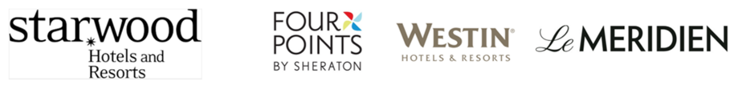

1. Hybrid.
2. House of brands.
3. Branded house.

# Module 4 Summative Assessment

**Question 1**

What question does a brand portfolio tackle?

1. How should I evaluate my next marketing campaign?
2. How should I use my brands to achieve top- and bottom-line growth?
3. How should I best structure and communicate my portfolio of brands?
4. How should I launch new brands?
5. What is the best strategy to negotiate acquiring new brands?

**Question 2**

1. Read the following situation and decide whether it is a portfolio question or a brand architecture issue:
2. "*You need to understand what is the impact of adding a “last name” to your existing brand. For example, if your product is Lemonlife, you are considering doing Lemonlife by ABC Industries.*"
3. Portfolio.
4. Architecture.

**Question 3**

Which of the answers below is a list of key criterion to evaluate when you FIRST DECIDE to expand your brand internationally?

1. Should we use an exclusive distributor, many non-exclusive distributors or open our own distribution channel?
2. Can we manufacture in that market from the brand’s launch?
3. Do we have an office in that location?
4. How fierce is the competition? How long have they been there? What is their presence and what are their customer loyalty levels?
5. Can I manage customer service in the local language?

**Question 4**

Which one of the below is not a sign that your organization might be suffering from a portfolio issue?

1. You have no clear brand-driven growth platforms to fuel future growth, but rather have to launch new brands every time you launch a new product.
2. You have overlapping brands in a portfolio offering with similar products/services targeted to the same customer.
3. There is no internal system for managing how new brands, or sub-brands are developed.
4. You are losing market share to old competitors and new entrants.
5. You are having to increase your advertising/marketing spending to get the same impact.

**Question 5**

Imagine that it is 5 years from now, and our Lemonade business has grown dramatically. We launched our lemonade business with the Lemon-Life brand below, and we are now evaluating other categories in which to launch products. Our goal is to grow our revenues 5 times in the next 5 years. R&D has developed the following pipeline of potential products.

Our brand:

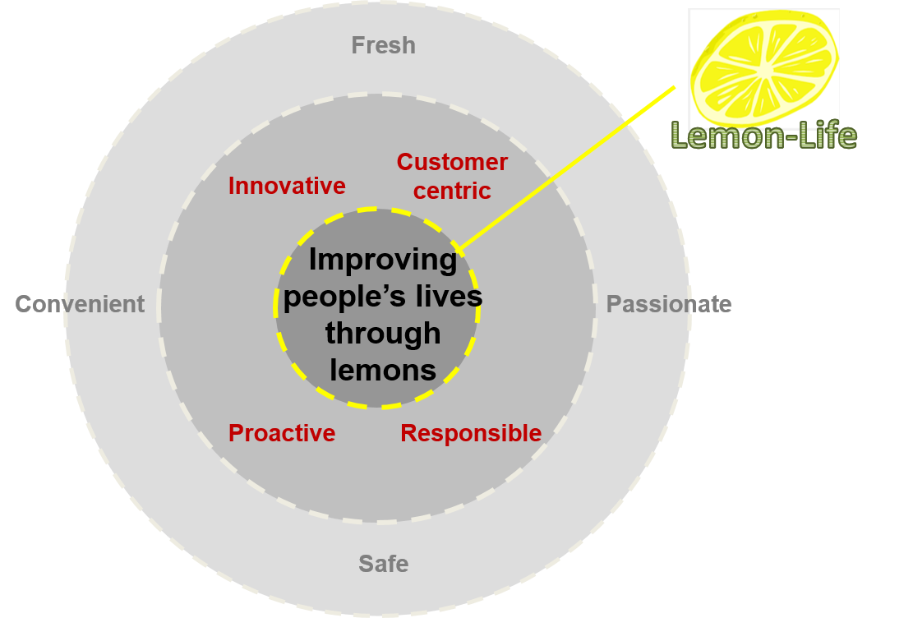

Our Pipeline:

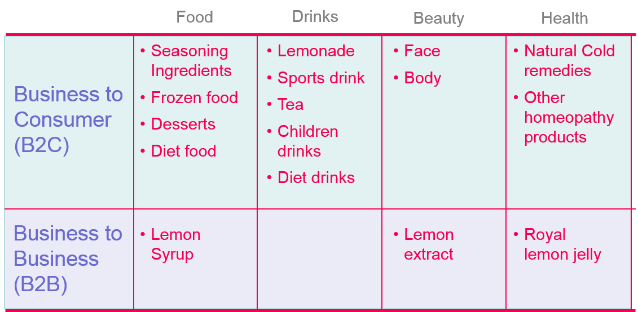

Which of the below questions should you answer before deciding under which brand you would launch each product?

a. Does this initiative generate sufficient revenues and return for on-going support to the brand / product?

b. If we use the Lemon-life brand, could it inhibit or take away attributes to the product’s brand promise?

c. Should we allow the launch team to decide based on their intuition?

d. Do we want all products associated with the same brand?

e. Do we need different brand essences?

f. Are there different Needs / Attitudinal segments within the potential customers?

g. Will we price them all in the same tier? Or will they be participating in different pricing tiers?

h. Is there a driver that can be leveraged to create a brand platform?

i. Do consumers behave the same in the different categories (i.e. how they use the product, where they buy, when they buy, why they buy)?

j. Should we maximize savings by using only one brand?

k. Is there fierce competition in the categories where we are launching the product?

l. How will each product’s revenues and margins be affected by the decision?

m. All of the above

n. None of the above

1. M.
2. A through to J.
3. D through to L.
4. N.
5. A through to C.

**Question 6**

Imagine that it is 10 years from now, and we have already made various brand decisions, and our brand portfolio looks like the one below.

Without any other information (i.e. consumer research, sales, etc.), please identify from the list below, which issues and opportunities your brand portfolio might be facing.

1. Can we grow the business by expanding into higher price / value tiers in Food, Drinks and Health?
2. Should we grow the business in the Luxury price tier using Citron Elixir?
3. Is there a potential brand overlap and confusion between Lemonyou and Lemonhealth?
4. Can a beauty brand also be in health care?
5. Should there be two brands in the value tier or is there a potential for more efficient allocation of resources?
6. Should we invest in Lemonbase as an ingredient brand for other products not manufactured by our company?
7. All of the above.
8. None of the above.

# Module 5 Summative Assessment

**Question 1**

In the text below, which phases of the purchase funnel are mentioned?

When searching for information for my next trip, I came across an advertisement of South Africa in a travel magazine. I went online and looked at the different itineraries that I could do in that country. I also read some of the reviews of hotels, attractions, bus and train options. I evaluated other options such as Zimbabwe, Kenya and Tanzania. Finally, I decided on South Africa and made my reservation through a travel agent in that country, who responded promptly to my request.

1. Influencing, Pre-purchase, Purchase.
2. Branded House, Hybrid and House of Brands
3. Magazines, Online Review sites, Travel Agent.
4. Awareness, Consideration, Purchase.
5. Essence, Values and Extended.

**Question 2**

Which one of the below is an example of a touchpoint?

1. Environmental Policy.
2. Sales clerk.
3. Fair trade.
4. Brand Awareness.
5. Friendliness.

**Question 3**

Which of the lists below best captures the different roles that your touchpoints can play in the customer experience?

1. Offline, Online, Mixed.
2. Branded Differentiators, Signature Icons, Category Redefiners and Guest Expectations.
3. Internal and External.
4. Company, Client and Supplier.
5. Introduction, Growth, Maturity and Decadency.

**Question 4**

Which of the examples below, best represent the pre-purchase touchpoints for our lemonade business?

1. Word-of-mouth from my friend, the posters on the street and the push message on our phones.
2. The décor of the stand, the music, the product (comprised of the actual lemonade and the cup), the ingredients, and the personnel (with their uniform).
3. Valencia - Spain, Recyclability, Hand made, Brown sugar, Cinnamon.
4. Loyalty card and next purchase promotion.
5. All of the above .

**Question 5**

In lecture 5.3, I described an interview with a hotel client. Using that information please select which of the lists below best exemplifies the touchpoints that represent the potential bottleneck for the family to move from the Purchase to the Loyalty phase of the purchase funnel.

(You can review the text of the specific part of the video in the file below).

1. Word of mouth, Hotel's web site, and the lobby.
2. The vases in the lobby, the connecting rooms, the bill.
3. Online booking, Bed, Shower, Reception staff for check in and check out, online review.
4. The elevator, the cue in the lobby, the bathtub.
5. None of the above.

**Question 6**

Using the matrix tool for evaluating touchpoints that was discussed in [l](https://www.coursera.org/learn/product-management/lecture/xUVEY/5-4-prioritizing-the-key-touchpoints)ecture 5.4, containing "ease if implementation" on the x axis and "relevancy for the customer" on the y axis, please decide whether you would invest, evaluate more or discard the following touchpoint for our lemonade business:

"A certificate that provides the specific origin and batch of each lemon used in your lemonade."

1. Don't invest.
2. Develop more.
3. Quick win - invest!

# Module 6 Summative Assessment

**Question 1**

What is the first step to define your internal communication and training program?

1. Identify which is the best channel to launch it.
2. Define a theme for your campaign.
3. Develop videos to promote your program.
4. Understanding who is your audience.
5. Identify who are the people that will appear in the communication.

**Question 2**

What is a crucial role to recruit when embedding the brand in your organization?

1. A graphic designer.
2. The Brand Champions (or Ambassadors).
3. An external consultant.
4. An HR specialist with experience in group psychology.
5. An internal communication person.

**Question 3**

What is the most important action to take when launching a brand engagement program?

1. Have your top management’s endorsement.
2. Launch a great tagline for your program.
3. Develop a comprehensive brand tool kit.
4. Give out bonus compensation for everyone who learns the brand values.
5. None of the above.

**Question 4**

The following 3 questions are related to the following mini-case.

Remember from Module 4, that we had decided to launch our lemonade business under the brand “Lemon-Life”. Imagine that we are now opening our 6th neighborhood kiosk. We have a workforce of 15, 2 per kiosk and 3 in a central facility coordinating everything from purchasing, marketing, HR, Finance, etc. Our biggest success is delivery, with sales growing 100% each month. We are beginning our brand engagement program. After an exhaustive process we defined our brand as:

If you are in charge of defining the metrics that we will use to measure on-brand behavior in our program, taking into account that this is a new brand and our employees have never had any formal training in our brand, which one would you use in our “Hearing Phase” and why? Please select a metric and rationale from the options.

**Metric**

a. Number of new products launched

b. Revenues

c. Referral

d. Brand awareness

e. Brand consideration

**Rationale: Because…**

f. Our brand will only be known by how many people purchase our lemonade.

g. Word of mouth and social networking recommendations are what will let future customers know who we are.

h. We want employees and customers to know what our brand is all about.

i. What is crucial is that our employees need to understand the customer’s decision making process.

j. The only way to continue growing is through the launch of new products.

1. d and h.
2. e and h.
3. d and i.
4. a and f.
5. b and g.

**Question 5**

(Refer to the example shown in question 4)

For our program we have chosen 2 Brand Champions and they are in charge of leading the teams to embed the brand values throughout the different touchpoints. Which of the below descriptions would you use as criterion for recognizing their behavior?

1. The number of customers that know our values.
2. The savings that they can bring to every touchpoint.
3. How well employees can recite our values.
4. The number of customers that they convince to buy more than one product.
5. Assisting fellow colleagues in guidance of what is considered on-brand behavior.
6. Policing everyone to ensure that they behave according to our values.

**Question 6**

(Refer to the example shown in question 4)

Given the description of our Customer Centric value, which of the following best represents a behavior that we would like our employees to have in the following situation:

"We have a line of customers and a woman has just been served. She steps aside and adds more sugar to the lemonade and when she tastes it, she dislikes it and complaints. What should our employee do?"

1. Tell her that they are sorry and they cant do anything about it because she modified the product.
2. Explain to her that our lemonade is made to be drunken as is and offer to sell her another lemonade without queing.
3. Change her lemonade for a new one.
4. Disregard her comments and keep on selling.
5. Offer her a “taster” of our lemonade without modifications, so she knows what she is missing.